# Project Documentation – Personal Finance Tracker

## 1. App Purpose & Features

The Personal Finance Tracker is a desktop application that helps users manage their income, expenses, and savings effectively. It provides an easy-to-use interface for adding, editing, and deleting transactions, setting monthly budgets, and visualizing spending patterns.

Key Features:  
- Add, edit, and delete transactions with details like amount, category, date, and note.  
- Set monthly budgets and receive alerts when they are exceeded.  
- Set budgets for each spending category (e.g., Food, Transport, Bills).  
- Track expenses with a visual pie chart using Matplotlib.  
- Toggle between light and dark themes.  
- Automatically reset monthly data with rollover savings calculation.  
- Search transactions by keyword.  
- Export transactions to CSV for backup.

## 2. Technologies Used

- **Python 3** – A high-level, interpreted programming language used to develop the application. It provides the logic, data handling, and integration with libraries for GUI, storage, and charts.  
- **Tkinter** – Python's standard GUI (Graphical User Interface) library that enables building interactive desktop applications with windows, buttons, and forms.  
- **ttkbootstrap** – A modern styling library for Tkinter that provides pre-built, attractive themes and styles to make the application's interface look professional and visually appealing.  
- **Matplotlib** – A powerful data visualization library used to create pie charts that show the user's expense distribution across categories.  
- **JSON** – A lightweight data storage format (JavaScript Object Notation) used to store transactions, budgets, and configuration data locally in easily readable files.  
- **CSV** – Comma-Separated Values format used to export transaction records so they can be opened in spreadsheet applications like Microsoft Excel or Google Sheets.

## 3. Setup / Run Instructions

Step 1 – Installed Python:  
Download from https://www.python.org/downloads/  
During installation, check 'Add Python to PATH'.

Step 2 – Install Dependencies:  
Open Command Prompt and run:  
pip install ttkbootstrap matplotlib

Step 3 – Run the Application:  
1. Download or clone the project repository.  
2. Open Command Prompt and navigate to the folder containing app.py.  
3. Run:  
python app.py  
4. The Personal Finance Tracker window will open.

## 4. Project Structure

finance-tracker/  
│  
├── src/  
│ └── app.py # Main application code  
│  
├── data/  
│ ├── transactions.json # Transaction history  
│ ├── budget.json # Monthly budget data  
│ ├── category_budgets.json # Category-wise budget data  
│ ├── app_config.json # Theme and rollover settings  
│  
├── screenshots/  
│ ├── main_menu.png # Main menu view  
│ ├── add_transaction.png # Add transaction form  
│ ├── summary_chart.png # Expense pie chart  
│  
└── README.md # Documentation

## 5. Sample Screenshots

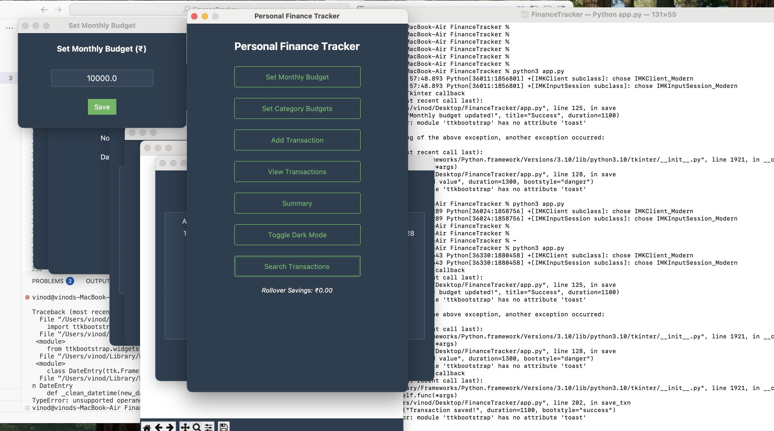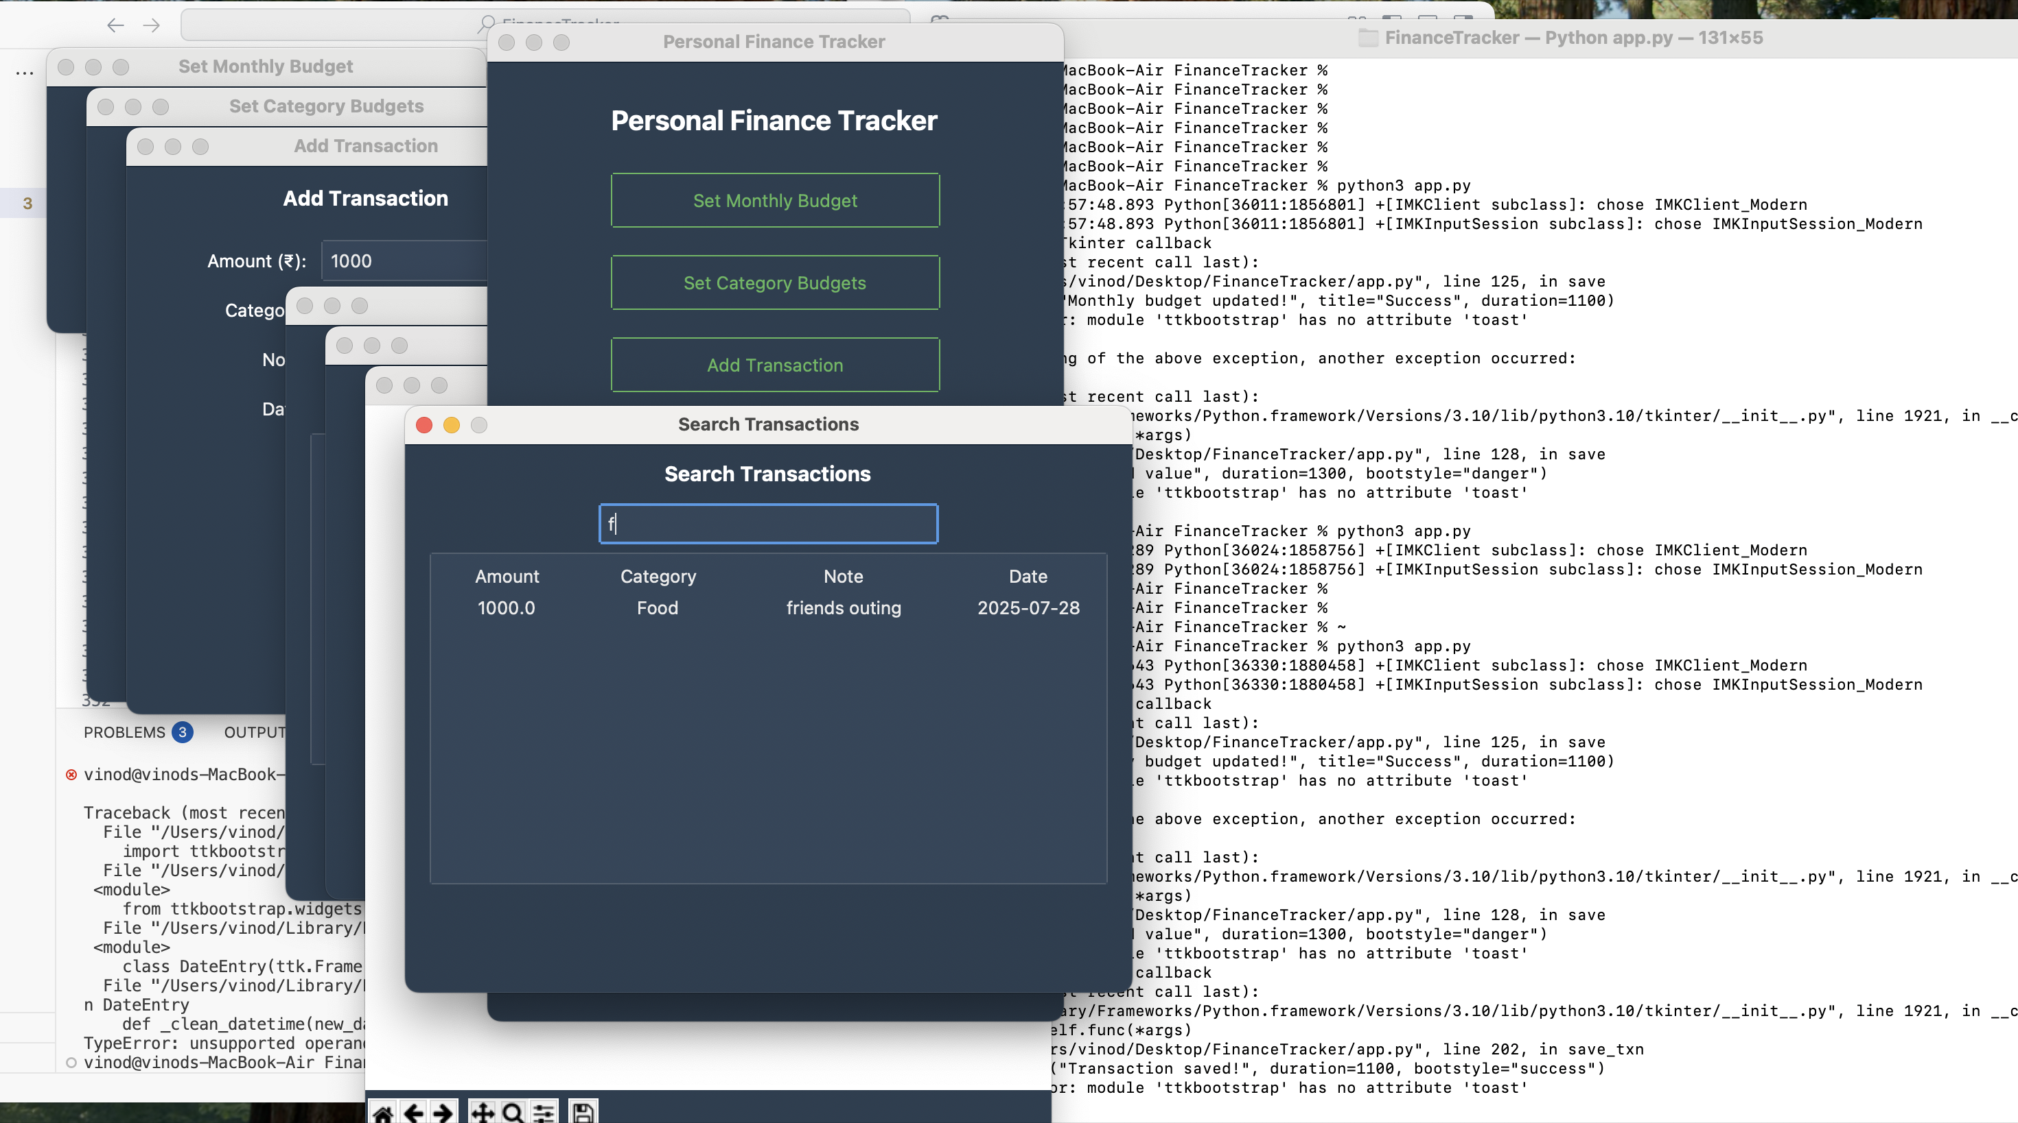

## 

## 

## 

## 

## 6. Bonus Features Implemented

✅ Budget tracking by category  
✅ Dark Mode toggle  
✅ Monthly reset with rollover savings  
✅ Transaction search by keyword